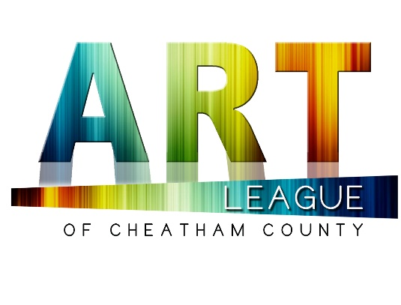

Juried Art Show Prospectus

About the Cheatham County Juried Art Show
This annual juried exhibit showcases artwork from artists all over middle Tennessee, with primary placement for members of the Art League residing in Cheatham County. The Art League strives to highlight artists in all stages of their careers and offers them a chance to compete for a number of awards. This show features artwork from an extensive variety of mediums and explores creative movements happening throughout our region.

Eligibility
Open to all living artists ages 12 and up, residing in middle Tennessee. All entries must be original, completed in the past five years, and have not won an award in a prior Juried Art Show of Cheatham County competition. All mediums are welcome.

Entries and Fees
PLEASE NOTE: There are two entry portals this year – one for ADULTS and one for STUDENTS. Please be sure you complete the correct application.

Artist may submit up to three entries. Entry fees are for consideration by the jurors, payment does not guarantee admission into the exhibit.

Juried Show: $25 per entry for members, $50 for non-members, Students may submit up to two entries free of charge. *Entry fees will be invoiced after acceptance and are non-refundable.

Deadline
All entries must be submitted in completion by March 2.

Accepted entries will be notified by March 6.

Accepted artwork must be dropped off at the Cheatham County Government Offices at Sycamore Square, located at 354 Frey Street between 9 a.m. – 12 p.m. on Saturday, March 21.

Art Exhibits will be on public display March 23-27 with public voting for the People’s Choice Award.

Art Show & Awards Finale at the Cheatham County Government Offices at Sycamore Square, 6 p.m. Saturday, March 28,

Awards
Best in Show: $1,000  People’s Choice: $500  First Place: $250, for each category  Second Place: $150, for each category  Third Place: $75, for each category | Student Awards  Best in Show: $500  First Place: $ 250  Second Place: $150  Third Place: $75
Honorable mentions and additional awards and scholarships to be announced at the Awards Finale.

Submission
Visit www.alocc.org to submit your work.

Jurying
This year’s exhibition will be juried and awarded by a panel comprised of Guest Jurors to be announced.

Notification
The results of the jurying will be sent to all submitting artists via email. Selected artists will be instructed on how to proceed and are required to agree to all terms outlined by the Art League of Cheatham County. Accepted artists are responsible for the transportation of artwork to and from the event location. Please make sure you are added to our mailing list and that you have white listed emails from info@alocc.org so you receive all communications.

Sales
In the event that a work is sold, the artist will receive 100% of the selling price. Works will be considered for sale at the price indicated on the entry form. Sold works may not be removed from the exhibit prior to the close of exhibition.

Insurance
Accepted works will not be insured by the Art League of Cheatham County. Insuring artwork is the responsibility of the artist.

